This homework assignment is based on Chapter 8 (Second Look at Classes).

**There are two projects, each worth 50%**

**Project #1**

UML DIAGRAM (See next page)

**#1 print screen the code with the output below here.**

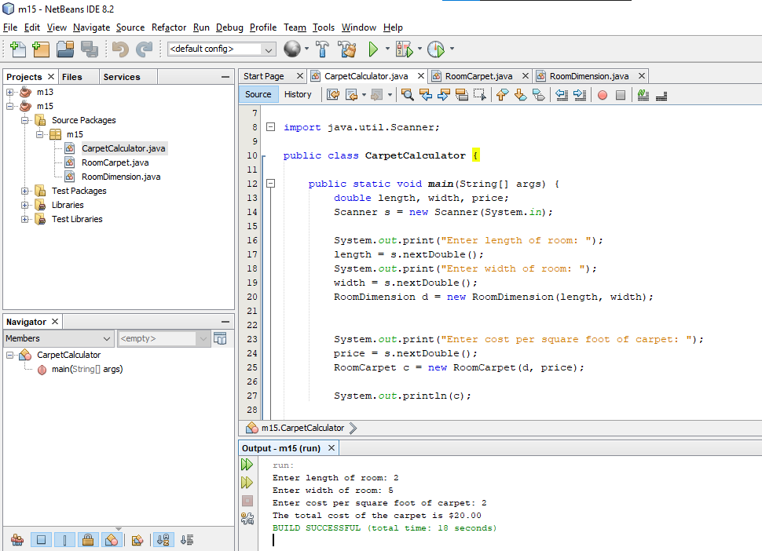 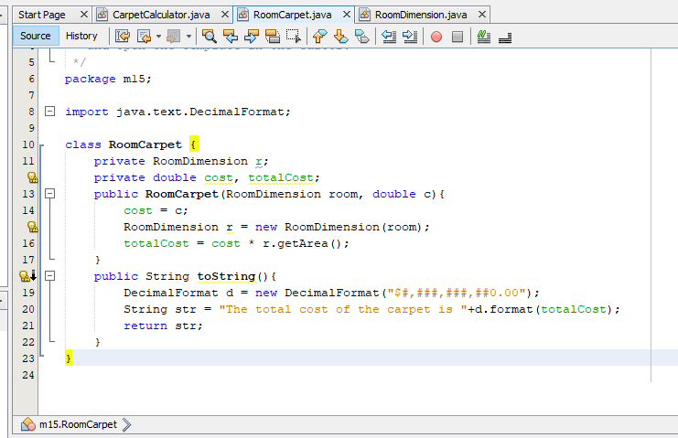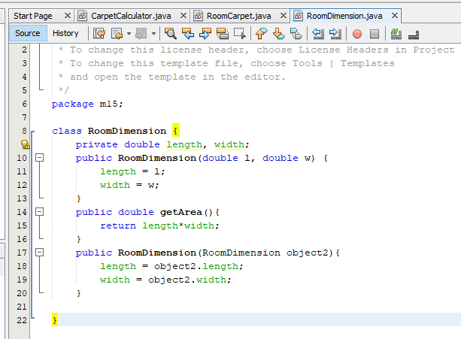

**Project #2**

**#2 print screen the code with the output below here.**

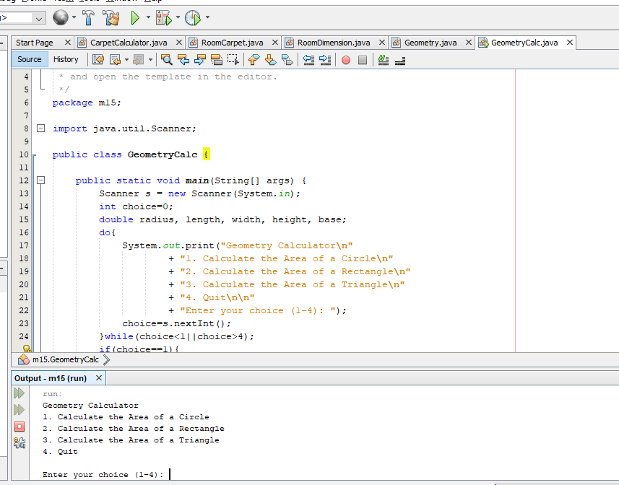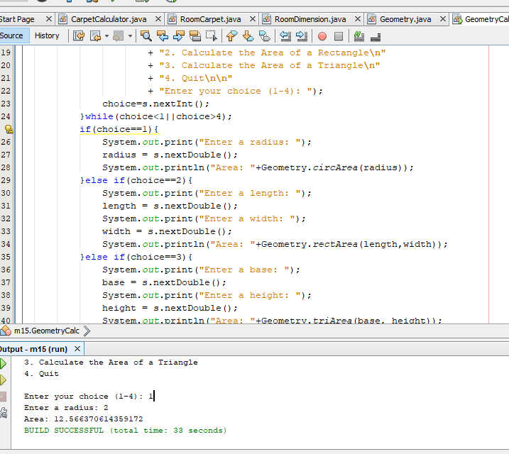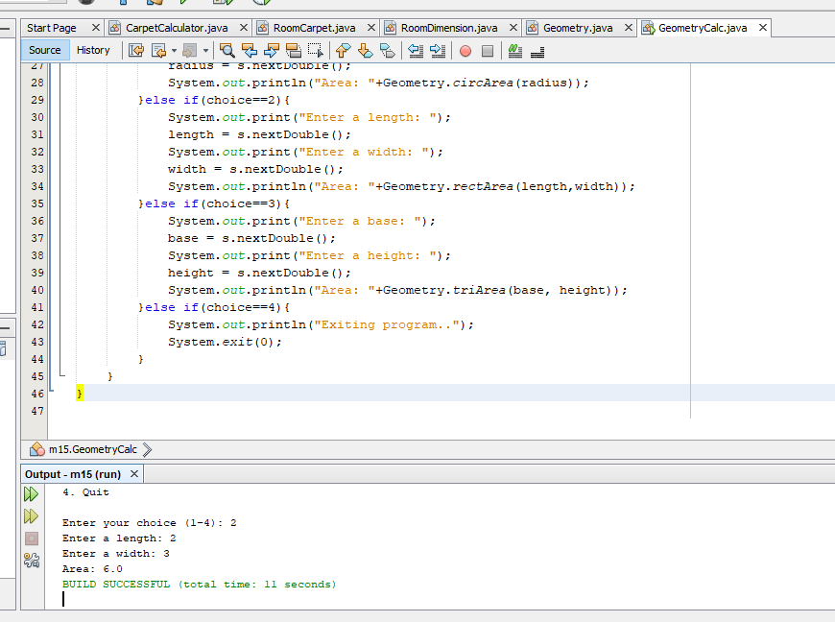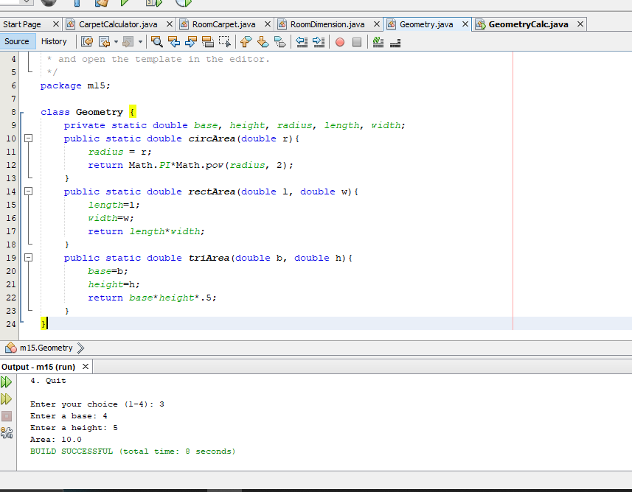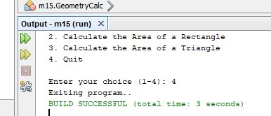

**Submit this document to Module 15 Homework.**